**Ex.no:4**

**Date:30/3/25**

**5. Create web form that accepts a user’s name and age.Write a servlet to process the form data and display it back on the browser.**

**Aim:**

Create web form that accepts a user’s name and age.Write a servlet to process the form data and display it back on the browser.

**Program:**

**User.html:**

<!DOCTYPE html>

<html>

<head>

<meta charset=*"ISO-8859-1"*>

<title>Insert title here</title>

</head>

<body>

<form

action=*"http://localhost:7750/Dynamic_web_project_muthulakshmi/DisplayUser"*>

<label for=*"name"*>Name:</label> <input type=*"text"*

id=*"first name"* required placeholder=*"hi user"* name=*"name"*> <br>

<p>

<label for=*"age"*>Age:</label> <input type=*"text"*

name=*"age"* id=*"age"* required>

</p>

<br> <input type=*"submit"* value=*"ACCEPT"*>

</form>

</body>

</html>

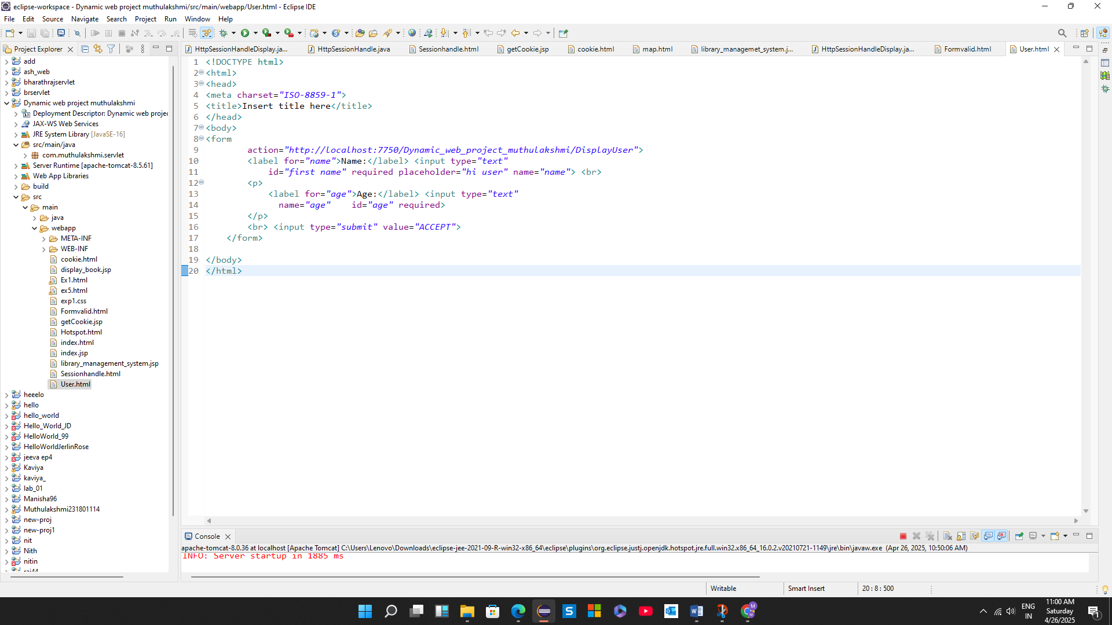

**DisplayUser.java:**

package com.muthulakshmi.servlet;

import java.io.IOException;

import java.io.PrintWriter;

import javax.servlet.ServletException;

import javax.servlet.annotation.WebServlet;

import javax.servlet.http.HttpServlet;

import javax.servlet.http.HttpServletRequest;

import javax.servlet.http.HttpServletResponse;

/**

* Servlet implementation class DisplayUser

*/

@WebServlet("/DisplayUser")

public class DisplayUser extends HttpServlet {

private static final long serialVersionUID = 1L;

/**

* @see HttpServlet#HttpServlet()

*/

public DisplayUser() {

super();

// TODO Auto-generated constructor stub

}

/**

* @see HttpServlet#doGet(HttpServletRequest request, HttpServletResponse response)

*/

protected void doGet(HttpServletRequest request, HttpServletResponse response) throws ServletException, IOException {

String a=request.getParameter("name");

int b = Integer.parseInt(request.getParameter("age"));

PrintWriter p=response.getWriter();

if (b > 0 && a!=null) {

p.println(a);

p.println(b);

}

else {

p.println("Enter valid age");

}

}

/**

* @see HttpServlet#doPost(HttpServletRequest request, HttpServletResponse response)

*/

protected void doPost(HttpServletRequest request, HttpServletResponse response) throws ServletException, IOException {

// TODO Auto-generated method stub

doGet(request, response);

}

}

**Output:**

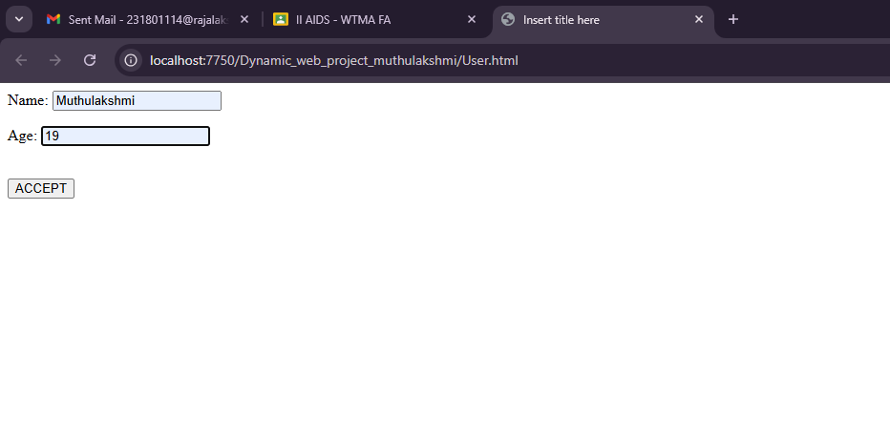

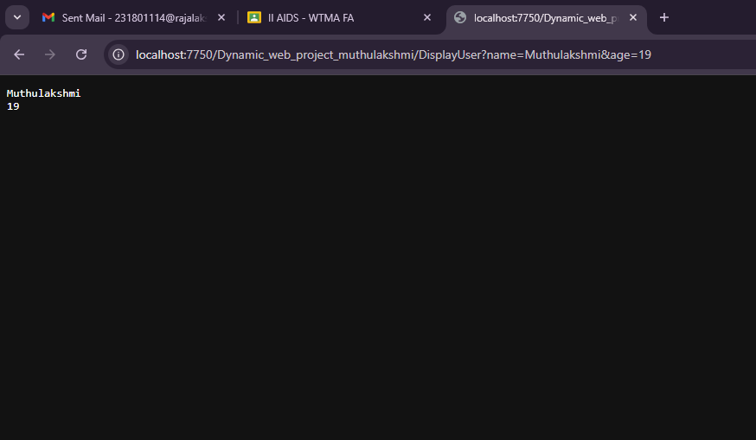

**Result:**

Thus the program was successfully executed.